DBMS Practical No.: 10

**Name: yash ajay magar**

**Experiment No 10**: Use Set operators to perform different operations

Exercise:

1. Consider following Schema :

emp1(empno,ename,deptno)

emp2(empno,ename,deptno)

Write SQL commands for the following statements.

1. Display the names of employees including duplicate employee names.

2. Display the names of employees excluding duplicate employee names.

3. Display the common employee names from both the tables.

4. List employees who are not assigned to any department?

1. Display the names of employees including duplicate employee names.

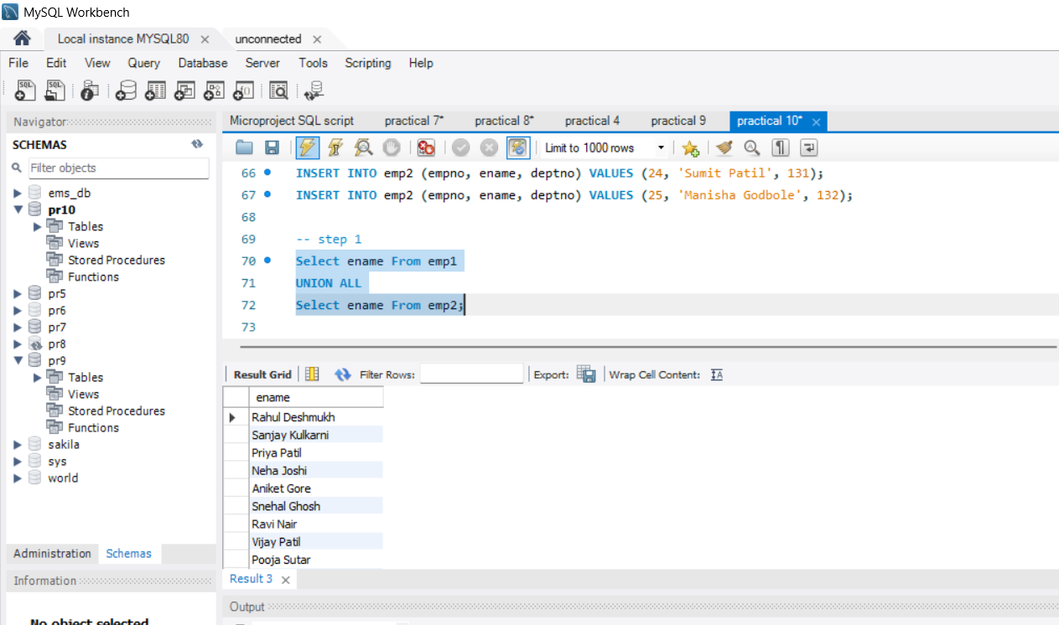

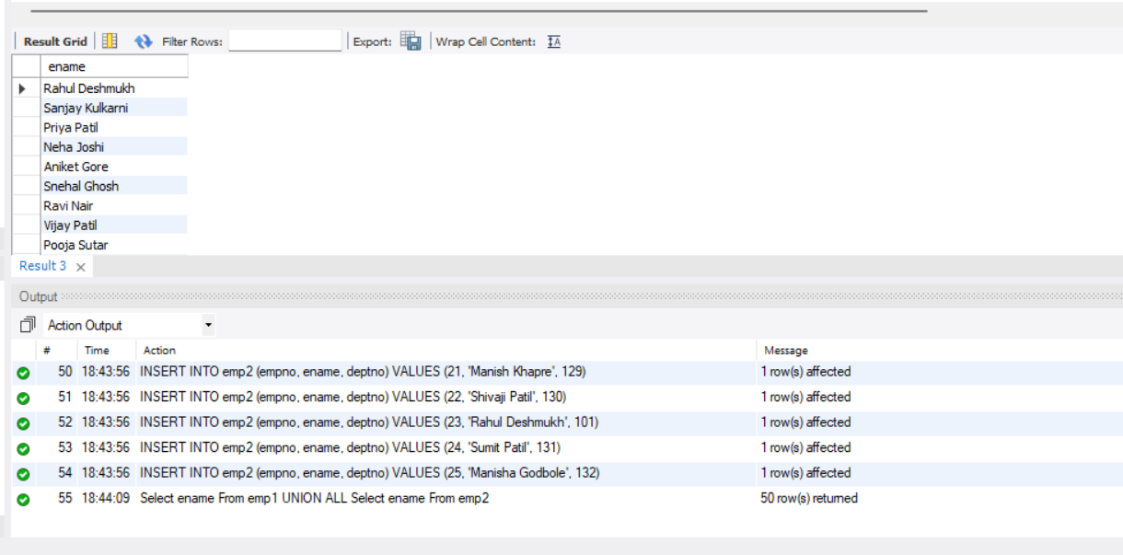

2. Display the names of employees excluding duplicate employee names.

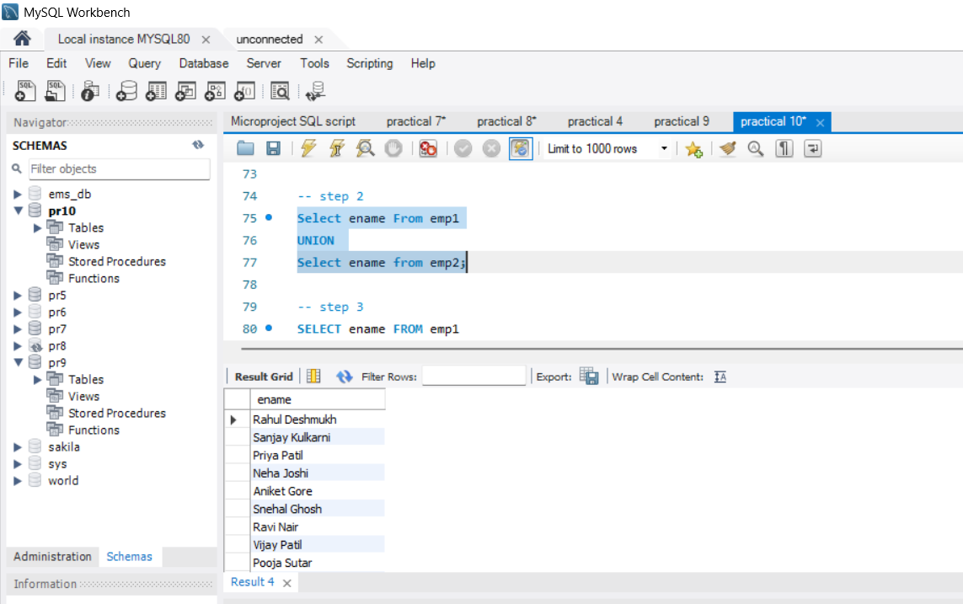

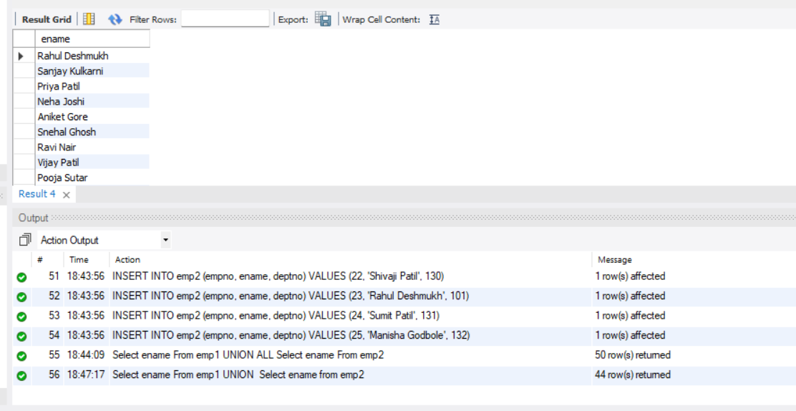

3. Display the common employee names from both the tables.

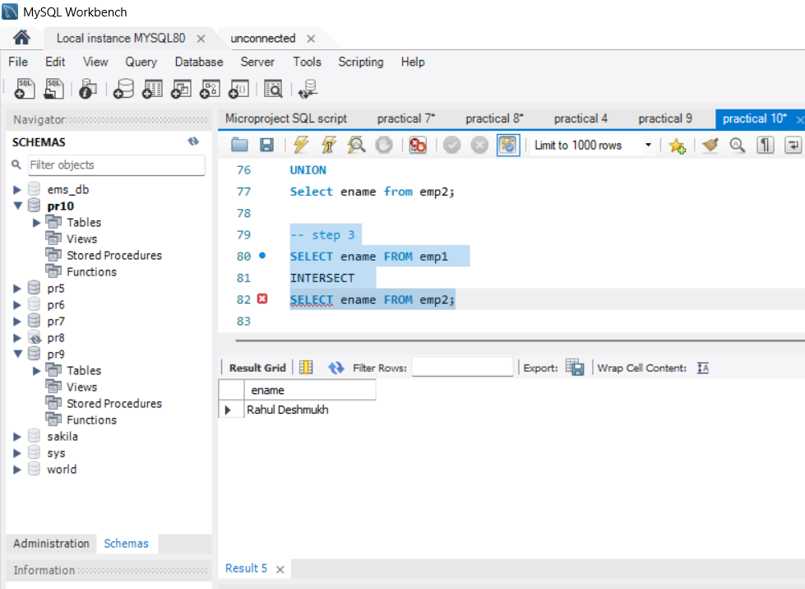

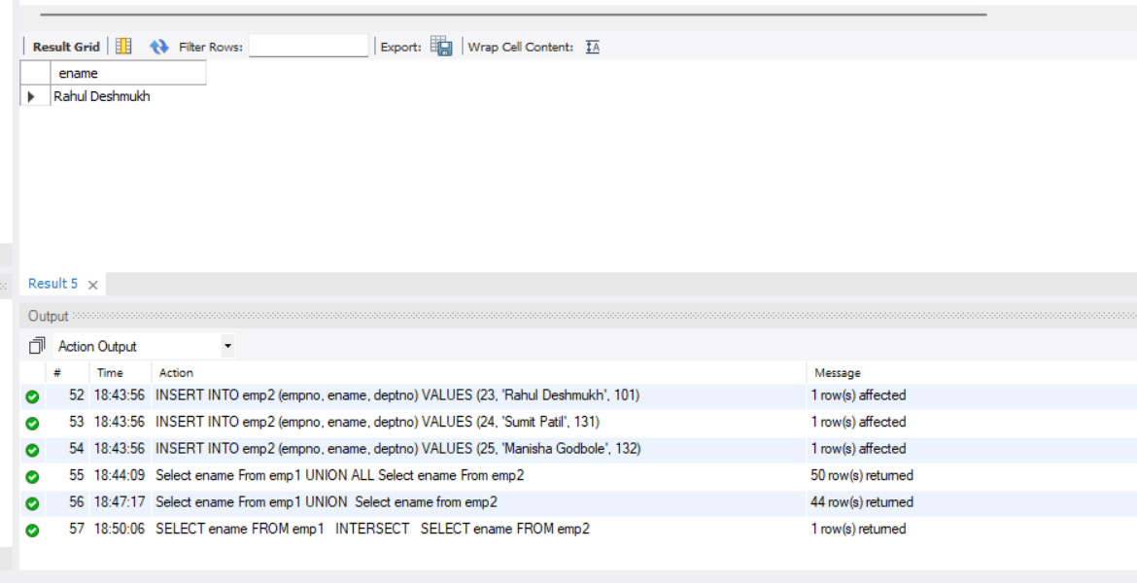

4. List employees who are not assigned to any department?

